Computer Graphic Assignment 3

Xiang Zhang CS560

The goal of this assignment is to enhance the concept of 3D viewing, and create the special effects using the basic geometric transformations. The realization of 3D viewing environment through your implementation will make you better understand some of the most important features of the graphics applications in 3D scenes display and rendering. By using the OpenGL API can achieve this task.

To run the code:

make

./project

1. Display.c contains the key parts of code for this assignment.

void RenderGLScene(int base_radius, int top_radius, int height)

This is the function of drawing v1. I draw a cylinder By using functions in OpenGL, like gluNewQuadric, gluCylinder,gluCylinder

The functions: Rollup,RollDown,PitchUp,PitchDown, YawUp YawDown SlideUp SlideDown implement the camera changing effect.

I implement v2-v4 within void RenderHierarchicalGLScene() function, where I use glrotated() to rotate the x,y,z vector and gltranslatef() for shifting.

By adding mouseDrag and mouseClick methods for mouse observation, I implement the function of moving camera in an arbitrary direction.

1. How to operate:

By click the left mouse and drag, you can see the cylinder’s rotating movement. Otherwise, you could make it by using the menu, which could shows up by right clicking the mouse.

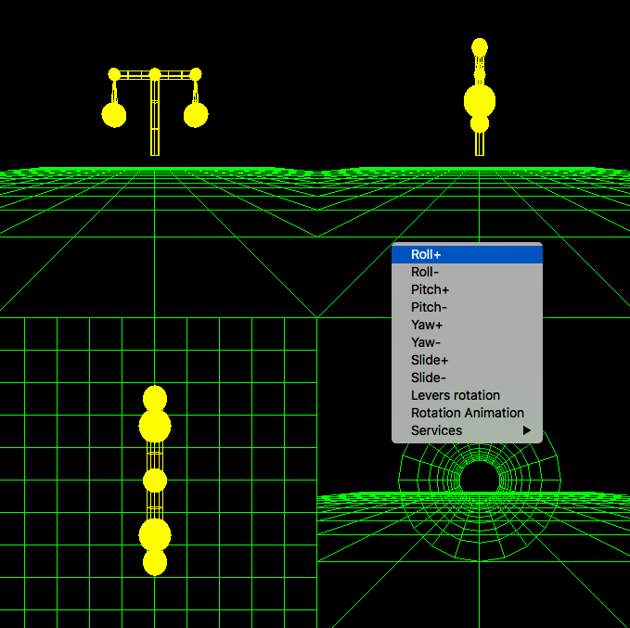

By the way, typing the ‘w’ and ‘s’ keys on your keyboard will show you the side- and side+ effect.

When you click the ‘Levers rotation’, the cylinders in v2-v4 will purchase one step motion.

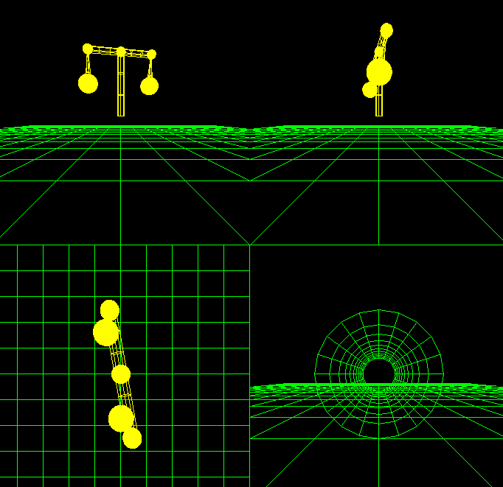

Furthermore, I implement the moving animation by clicking the Rotation Animation in the menu bar. The cylinder would keep moving until you select the menu next time.

All this rotation are implemented by these global variables:

double m_xtheta=0;

double m_ytheta=0;

double m_ztheta=0;

double m_slide=40;

double lr_ythetha = 0;

double lr_zthetha = 0;